Tableau Workshop

## Line Chart - Sales by month for any year

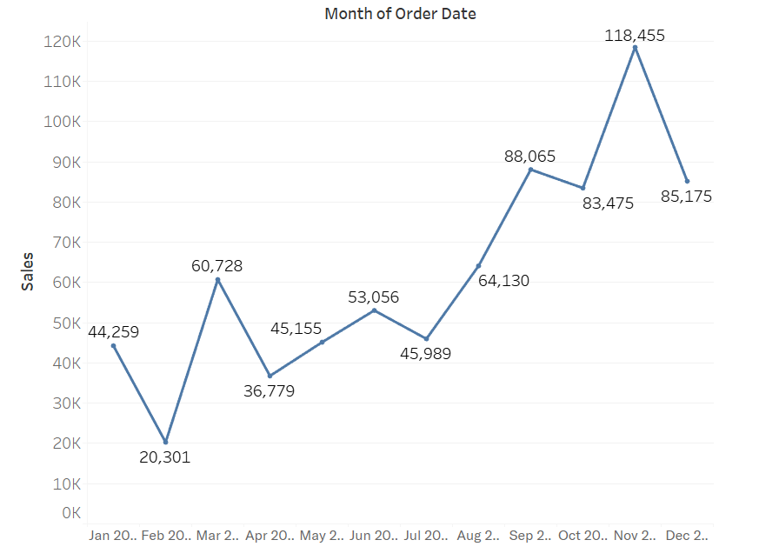

## Bar Chart - Profit by Product

## Geographical map – Order count by State/ Province

## Pie chart - Sales by segment

## Stacked bar chart - Quantity by Ship Mode

